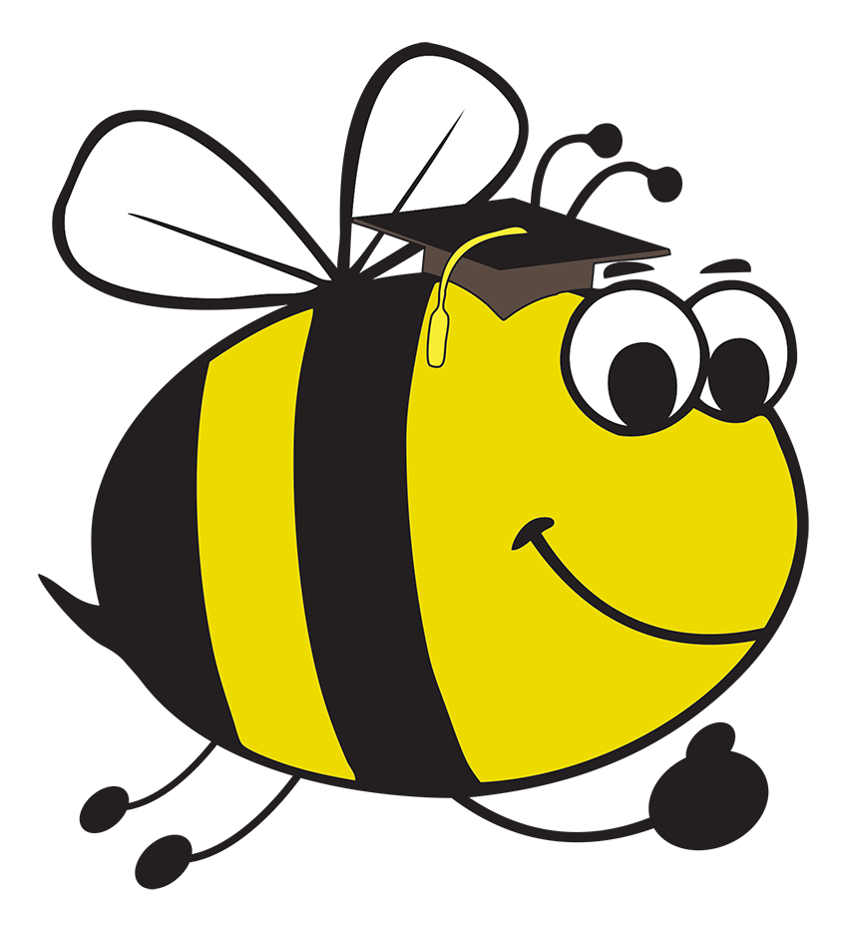
list 1 | list 2 | list 3 | list 4 | list 5 | list 6
ck words 1 | ck word 2 | all and ell words | ill words | ff and ft words | ss words
back | neck | all | bill | cliff | off
pack | peck | ball | fill | sniff | gift
rock | lock | call | hill | stiff | lift
sack | rock | fall | kill | puff | left
kick | sock | hall | mill | stuff | soft
lick | duck | tall | pill | off | cross
pick | luck | wall | still | gift | miss
sick | muck | bell | sill | lift | across
tick | suck | fell | till | left | fuss
deck | tuck | sell | will | soft | bless

Name:
Lists 1-6 Set C www.links2learn.co.uk

Word Lists – 1 - 6 (Set C)

